**Regents Earth Science: Lunar and Solar Eclipse Handout**

Name:_____________________________________________________

1. **Lunar Eclipse**
   1. What exactly is a lunar eclipse and how often do they occur? ____________________________________________________________________________

____________________________________________________________________

* 1. Explain why a lunar eclipse does not occur every month as the moon passes behind the Earth’s shadow

_______________________________________________________________________________

______________________________________________________________________________

* 1. Label the following diagram below : Use the terms “Earth, Moon, Penumbra, Umbra, Sun”

[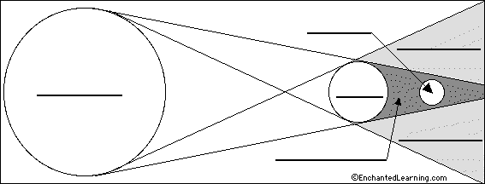](http://www.enchantedlearning.com/label/astronomy.sht)

* 1. What phase of the moon always occurs during a lunar eclipse? ___________________
  2. What part of the Earth’s shadow do we pass through in a total lunar eclipse? _________________
  3. What part of the Earth’s shadow do we pass through in a partial lunar eclipse? ___________________

1. **Solar Eclipse**
   1. A solar eclipse must be viewed using special glasses to block out the sun’s harmful rays from the corona. Label the diagram below using the terms sun, moon, earth, umbra , penumbra

[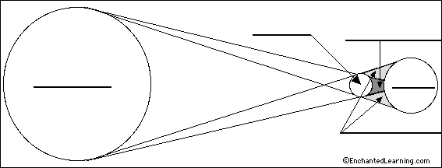](http://www.enchantedlearning.com/label/astronomy.sht)

* 1. In a lunar eclipse, the Earth’s shadow is cast upon the moon, blocking it out, however, what shadow is cast upon the Earth during a Solar Eclipse? ________________________________________________

__________________________________________________________________________________

* 1. The sun is 416 times times larger than the moon. Explain why you think it is possible that the moon blocks out the sun in the path of its orbit if it is this many times smaller! How is that possible?

__________________________________________________________________________________

___________________________________________________________________________________

* 1. A solar eclipse only occurs every 200 years in the same location on Earth but every 18 months in general. Using the moon’s shadow in comparison with the Earth’s shadow, explain why a solar eclipse is so much rarer than a lunar eclipse.

________________________________________________________________________________________________________________________________________________________________________

* 1. What lunar phase is always occurs during a solar eclipse? _____________________
  2. What part of the moon’s shadow do we pass through in a total solar eclipse? ________________
  3. What part of the moon’s shadow do we pass through in a partial solar eclipse? _________________
  4. The following diagram is depicting which type of eclipse? ______________________



* 1. The diagram below represents an observers photographs taken at several time periods over the course of one night. Which type of eclipse is occurring? _________________
  2. Explain why one could not explain this phenomena to be the result of the monthly phases of the moon

_________________________________________________________________________________

_________________________________________________________________________________

      